**Task 1**

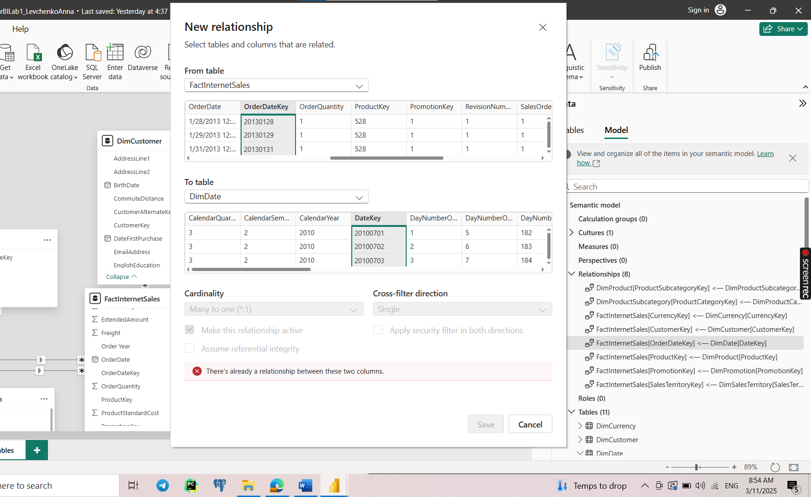

**Task 2**

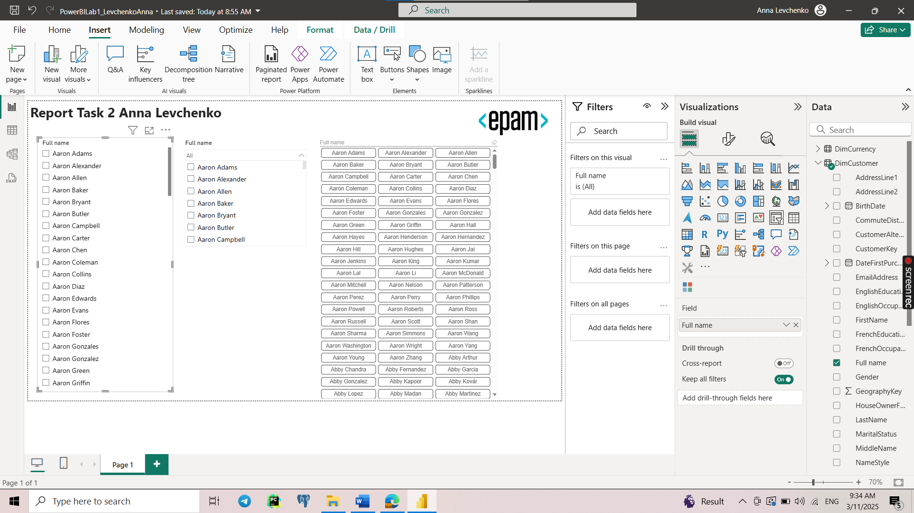

**Task 3**

3 slicers – dropdown, list-box and between. 5 visual types from standard list – clustered column chart, line chart, table, pi chart, stacked bar chart. 2 custom visuals – radar chart and word cloud. Also after 6 subtask a map was added.

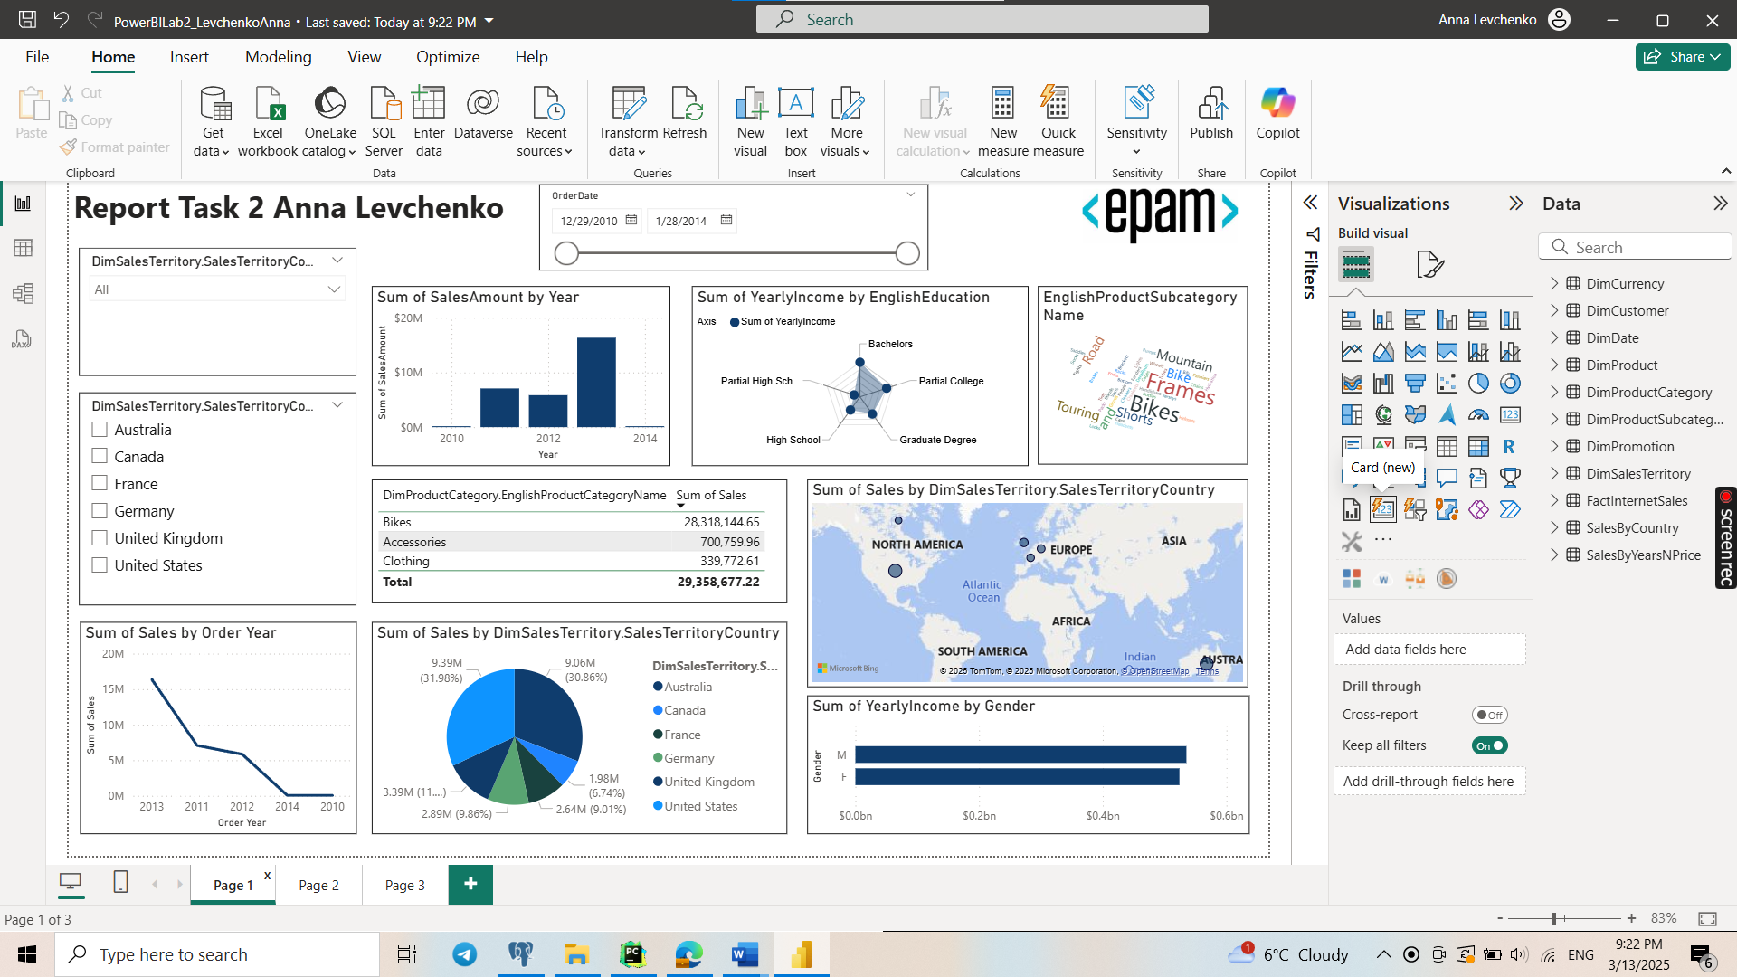

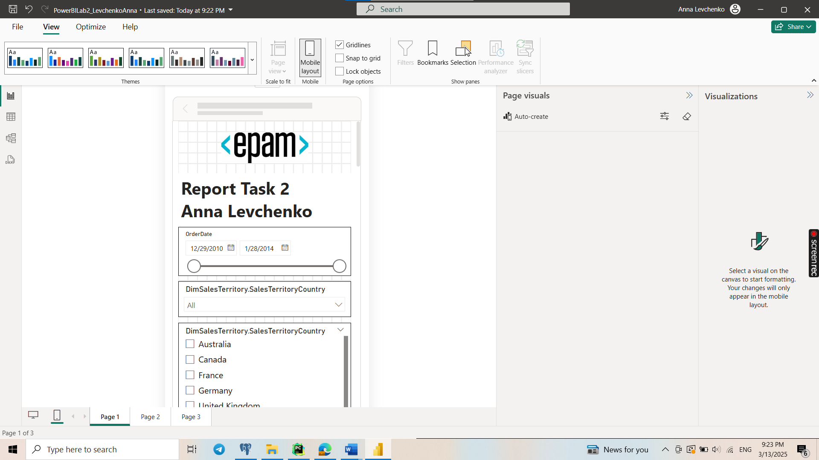

Disabled interaction between slicer (list-box) and table.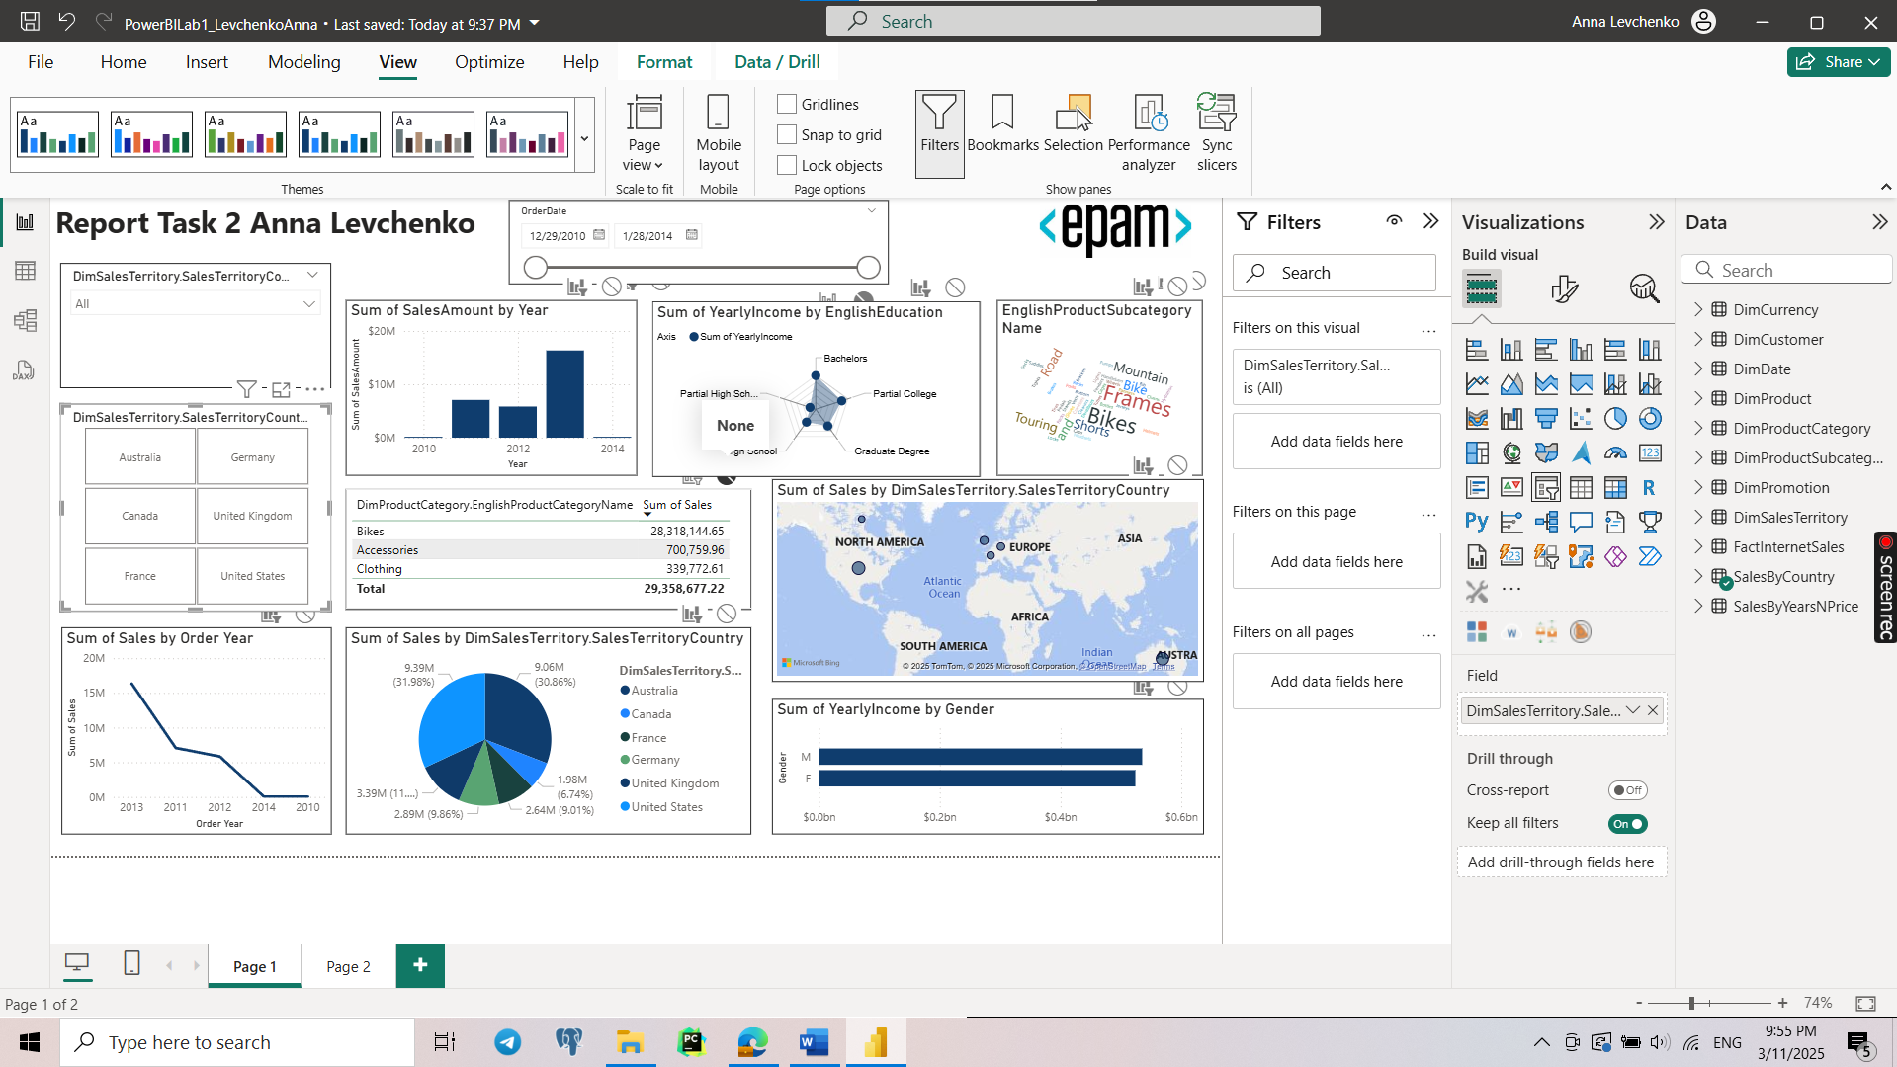

Published:

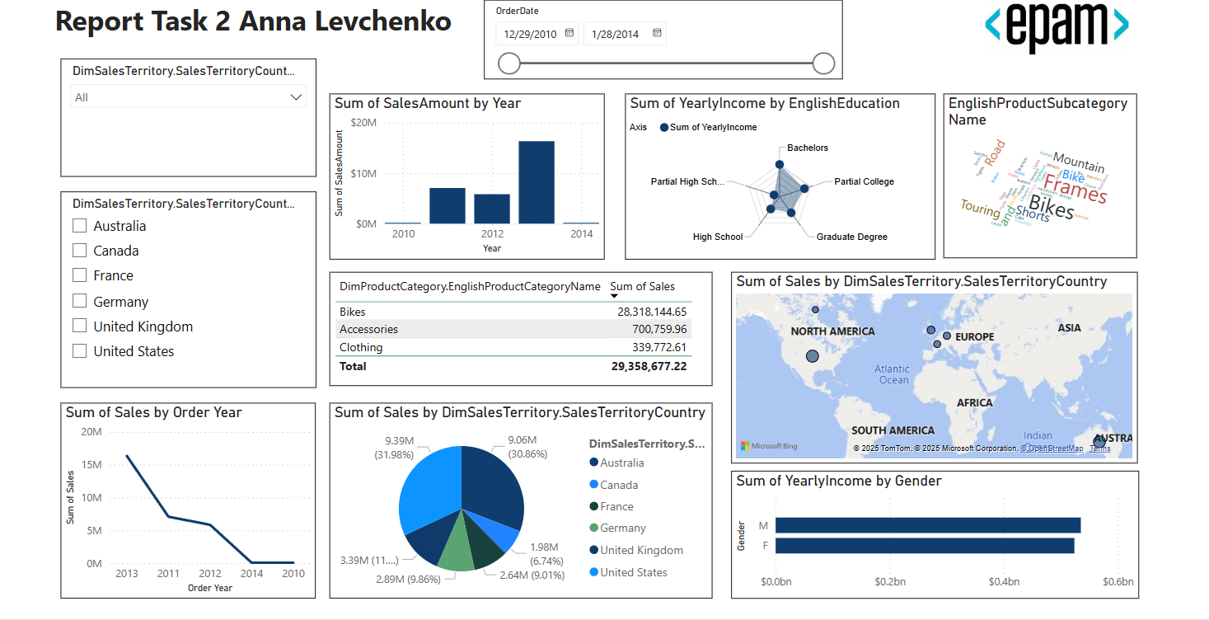

https://app.powerbi.com/links/9xIVQ8ND0M?ctid=b41b72d0-4e9f-4c26-8a69-f949f367c91d&pbi_source=linkShare&bookmarkGuid=55716b25-3051-4688-8de9-bbcf9031a389

**Install Personal Gateway and configure data refresh once a day.**

I tried to do it, but because previous task I have done on another computer, my report has different server

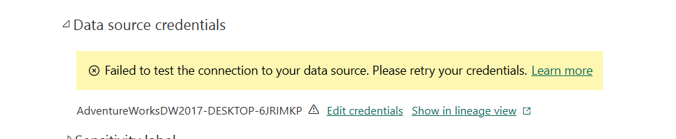

And currently my laptop has

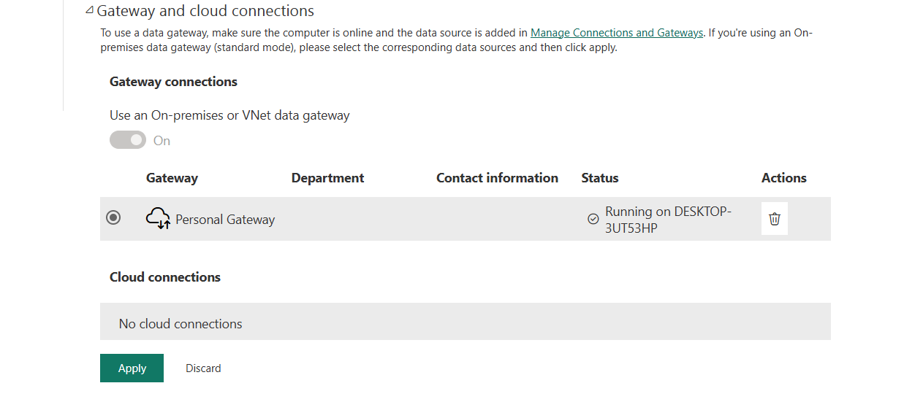

I tried again to connect report to dataset from my laptop, but it stacks each time at ‘evaluating process’.

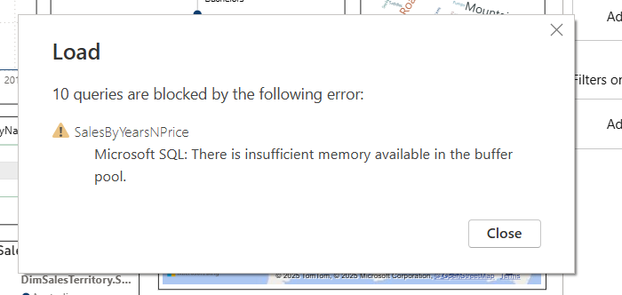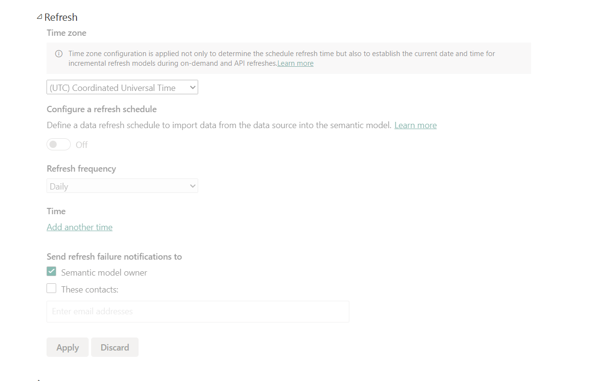

So, I understand that for refreshing I should change here settings that now is disabled for me.